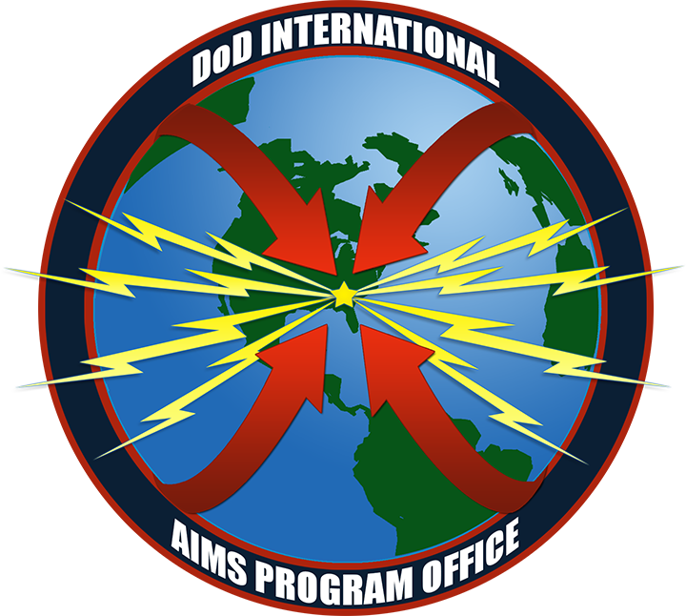
Dear TCFer!
Welcome back to the TCF newsletter August 2023! It’s been a while since the last newsletter and as the TCF is drawing closer it’s time for an update on this exciting event.
TCF 2023 Event information
Firstly please find a reminder on the TCF 2023 event information:
TCF welcomes you to the US Museum of aviation at Robins AFB, GA, USA 18-20 September 2023. This year’s TCF is being supported by the great girls and guys of the US DoD AIMS Project office who are based at Warner Robins AFB.
The conference fee to attend the TCF event is 50 US$. The conference fee includes conference facilities, morning and afternoon refreshments (coffee) for the whole TCF event. The conference fee shall be paid in on the first day at the registration counter in cash please.
The subscription for attendance to the TCF 2023 has been very high. However, registration and request for submissions for presentations is still open on TCF webs site www.tactical-comms-forum.com along with further details of the event. However, the agenda is now pretty full so it may not be able to accommodate presentation requests.
The TCF will not make a block booking at a hotel. However, TCF recommends delegates to book at one of the following hotels in Warner Robins Watson Boulevard area. Suggestion is to book one of the hotels in this area: hotels - watson blvd – Google Hotel Search Please book early to ensure a room for the TCF.
The Warner Robins Watson Boulevard area is approximately a 10 minute drive to the Air Force museum.
The recommended international and domestic airport to Warner Robins is through Hartsfield Jackson, Atlanta and then circa a 2 hours hire car journey (in a slow car ) to the TCF hotels.
We are currently planning a self-funded Social event at restaurant in the vicinity of Warner Robins. This is planned to be on the evening on day 2 (19 September 2023).

Event Location

TCF 2023 is being held at the prestigious location of the Museum of Aviation at Warner Robin AFB GA, USA.
The Museum of Aviation foundation is home to many interesting and historical aviation exhibits both in indoor exhibition halls and in the outside surrounding outside area and grounds of the museum.
More information of the museum of aviation can be found at their website Museum of Aviation Foundation: Supporting the U.S. Air Force Museum
Agenda discussion topics
The agenda for the TCF is driven and developed by proposals from the delegates to and provide interesting topics for and discussion within the meeting.
The interesting presentation topics for the TCF 2023 are:
- AIMS Project Office update and IFF Mode 1, 2 sunset

- Trendspotting; AI, Quantum computing, DNSL and its effect on cryptology

- NATO AWACS - Link16 Crypto Modernization (CM) Challenges - An Engineering Perspective

- NATO BU2 upgrade projects at NAEW&C

- New Link 16 terminals capabilities

- Network Planning for Link 22

- AN/ARC-210 radio, Airborne Communication System

- COMSEC management

- IO management of Interoperability enablers

- Resilient Autonomous Networking for Multi-Domain Operations

- IFF and TDL Integration in Modern C2 Systems

TCF 2023 are from:

Sweden’s Defence Materiel Administration (FMV) Swedish Armed Forces
NATO AWACS US DoD AIMS IFF Project Office
US DoD US DoD NAV AIR
US Navy US Airforce
US Air Force Base Warner Robins Austrian Armed Forces
Metra Saab Group
Collins Aerospace ATEQ
SyntheSys Curtis Wright
Leidos L3 Harris
Combitech HX5
Sylog Byss

Final remarks
The TCF 2023 agenda and detailed meeting information will be sent out to registered delegates within the next few weeks.
If you haven’t already registered your attendance please do this as soon as possible at the TCF website Registration | tacticalcommsforum (tactical-comms-forum.com)
We are very much looking forward to seeing you at Warner Robins in September 2023 for an interesting TCF.

Al and Kurt

